Optimization of Work Flow compared to the Previous System for the Operations and Maintenance Department of Weather.com.ph

By:

Adrian D. Tobias

Joanna D. De Guzman

Miguel S. Mayor

1. Introduction

Nowadays, arrangement and management of data has different techniques for different company around the world. These techniques help these companies to increase productivity. With productivity at a high level, surely income will increase too. This study focuses on the improvement on the old algorithm by assigning a new algorithm for the company called Weather.ph. What is Weather.ph? Weather.ph is a company under Aboitiz Equity, and its primary goal is to make all the people in the nation aware about the weather in the different regions of the Philippines. They handle the installation and operation of the weather machines. They have a problem existing in their system which is presentation of data this study makes use of its gathered information and data to focus on exploring that problem.

* 1. Project Context

In the Operations and Maintenance Department of the company called Weather.ph, they handle the data of weather stations and do maintenance on them. Based on the research, there are over hundreds of weather stations which are located all over the regions of the Philippines. From the farthest point in the north which is in Itbayat, Batanes to the farthest point in the south which is in Sulu holds weather stations that delivers important data. But there is a specific problem which arises inside the department and that problem is their arrangement and management of data is obsolete by today’s standard. They’re still using Excel as a means of arranging the information of the weather station and their data and documents about weather stations are just backed up in the manager’s computer.

What the Operations and Maintenance Department needs is a new system where in their data and documents are arranged and managed in a way where in there is order and no confliction in productivity occurs. Another feature of the system could improve work flow of the department therefore increasing the productivity and providing room for improvements.

* 1. Purpose and Description

The study of this analysis on how to arrange and manage data will result in a method which will solve the problem that the Weather.ph is now facing. This method when applied to a system would significantly improve the ease of arrangement and management of data within the company. Specifically, the system will be greatly beneficial to the operations department of the company in improving the productivity of the workers and the work flow itself. The system will not only bring productivity to the department, but also increase the reliability against the loss or errors that could occur from the data and documents that they handle.

* 1. Objectives

The researchers of the study have decided that the following are the main specific objectives of the study:

- To improve the algorithm to a better and faster way which its productivity is increased by 50%

- To come up with a proposal of usable methods that can lead into create a algorithm that will solve the problem of Weather.com.ph completely

- To gather all information and data from such sources like the interviewees, terms and definitions of problem, and related article which contributes in finalizing the best method for the problem.

1. Review of Related Literature

Weather Stations

Weather stations are devices used by several weather-related companies that, as the name implies, collect data that are related to the weather and environment. These weather stations use multiple sensors to be able to forecast and analyze weather. The sensors that are usually included in a weather station are barometers that measure the atmospheric pressure, thermometers to measure the temperature, hygrometers that measure the percentage of water vapor in the air or humidity, wind vanes that could tell the direction of where the wind is blowing, anemometers that measures current, peak, and average wind speeds, rain gauges that measures rainfall, and several other sensors depending on the manufacturer. Weather stations aren’t just for professional use, there are also weather stations being sold for home use. (Acurite, 2010)

Weather stations also come in two main types, manual and automatic stations. Manual weather stations are the traditional weather stations which are analog when measuring certain weather data. On the other hand, automatic weather stations, or AWS, have two main parts which are outdoor and indoor. The outdoor components of an AWS are the sensors that collect weather data, which then is sent to the indoor component of an AWS that displays the measurements and readings of the AWS. Many people, up to this day, still use the traditional manual weather stations, while many companies have migrated to the usage of an automatic weather station. One difference between a manual weather station and an automatic weather station is cost, with the latter being more expensive. (Moore, 2016)

Barcode and RFID

Barcoding, or barcode system, is a form of collecting data and an identification tool which does not require the use of physical keys. Barcodes are the black bars with gaps which are parallel that hold data contained in binary coding. Barcodes nowadays also come in other shapes such as rectangular ones. Each individual barcode has a unique pattern or shape that can correspond to an item or object. These barcodes are read using optical lasers which can interpret numerical and alphanumerical characters. According to Zebra Technologies, several forms of manual data collection and data entry has been replaced by the barcoding system. This is because the speed, as well as the accuracy, at which data is retrieved by barcoding is extremely quick and accurate. Zebra Technologies state that these barcoding systems are accurate 99% of the time. This is important due to the fact that data entry errors could cause negative effects on a business such as a wrong input of data within a manufacturing company could cause a decrease in production due to wrong values. (Zebra Technologies, 2013) Barcode technology could greatly impact the back-end of a business for numerous reasons. One of which is an improvement of the accuracy of data. This alone could possibly be the main intention for implementing a barcode system. The reason for its accuracy is due to the fact that the information are kept within the individual barcodes itself in which almost no human error could occur. According to BarCode ID Systems, the implementation of barcoding could greatly decrease operating expenses and have a noticeable return of investment with 6 months. Research also shows that barcode could increase warehouse operations inventory accuracy to about 99%. (Barcoding Inc., n.d.)

RFID, or Radio Frequency-Identification technology, is another type of tool used for data collection and uniquely identifying an item, similarly to barcodes. RFIDs contains a tiny chip and an antenna. As the name implies, RFIDs use radio frequencies to communicate with an RFID tag, or a transponder that contains information, which is interpreted using a transceiver that could interpret data. On paper, RFID is more sophisticated than barcodes with features such as farther read distances, faster read and write speeds, larger data capacity, higher levels of security, and many more. RFID systems also have their downsides though. Its drawbacks include higher pricing since it contains a computerized chip, and reader and tag collision errors when multiple readers and tags could cause errors to one another. (adaptalift, 2012)

Preventative maintenance

Preventative maintenance is maintenance that is regularly performed on a piece of equipment to lessen the likelihood of it failing. Preventative maintenance is performed while the equipment is still working, so that it does not break down unexpectedly.

According to Stuart Smith of MINTEK, many companies still do not consider applying preventive maintenance to their equipment and only acting when the actual equipment has broken down or failed, causing expenses to rise for the company for the replacement of the broken equipment. Preventive maintenance has several advantages, one of which is that preventive maintenance could decrease the expenses of the company. Even though preventive maintenance is also expense for the company, the cost of preventive maintenance is lower, compared to the actual replacement of the same equipment. The second advantage is the increase of efficiency of the equipment, making the equipment run more cost effectively. Equipment that has 100% health would utilize energy or power resources better than low health equipment. Preventive Maintenance could also indirectly increase the reputation of the company. Since the goal of preventive maintenance is to reduce the likelihood of a failure to occur, the company's history or track record of failure in their equipment would be minimal to none.(Smith, 2012) Preventive maintenance lessens the number of large-scale repairs as well as improves the safety and quality conditions of the people working with and around the area of the said equipment.

According to Ken Staller of Daniel Penn Associates, there are six steps to devising a preventive maintenance program. The first step of preventive maintenance is by reverse engineering what the company want to achieve by designing the procedures and identifying the possible problems or failures that may occur to the equipment. Also, the architects of the preventive program must be knowledgeable of the equipment or machines, they must know how it works and what to do at failure of the equipment. The second step of devising a PM program is to know how to efficiently handle the use of people and resources. First, the company must have a Computerized Maintenance Management System, or CMMS, in order to effectively handle the data about the people and resources, and the procedures. Next, the right procedures must be written and sent to the CMMS. After that, these procedures must be scheduled. The 3rd step is proper preventive maintenance lubrication engineering. This step is basically proper maintenance of lubrication of the equipment, and handling oils and grease as well as proper disposal of these oils and greases according to the environmental rules depending on the area. The fourth step is to train the staff for correct and proper preventive maintenance. Make sure the staff knows how to operate, repair, and maintain equipment according to how they were trained. The 5th step is having a management plan for the PM program. A proper management plan is effectively attains information that could be useful for future analysis. Such information include labor-hours, quantity of materials, reason for specific Work Order, etc. Lastly, the sixth step is to make sure communication to the workers is present. Communication is key in almost all programs and systems. Not having communication to the workers could cause misunderstandings to as why they are required to do such tasks. Communication must be present so that the workers of the PM program would know what exactly should be done, who will do this certain task, and when it should be done. Also, they must know what quality of work must be done.

III. Technical Background

The system will be incorporated as a web application which will cater to the needs of the Operations and Maintenance Department since they have roaming technicians that goes to sites where weather stations are placed. This web application has the ability of having a CRUD operation on service reports of the department. It will also present all the needed information about the specific weather station when the need of knowing that information occurs.

The first process in this web application is that it could generate service requests that are to be forwarded and given to the Operations and Maintenance Department for proper work flow of the department and improving the productivity. Then it is received by the Operations and Maintenance Department so that they are noted that some weather stations are due for a maintenance. The technicians in the department will conduct two solutions for the maintenance; either through contacting the site manager or through direct interaction on the machine. If the technicians uses the first solution, the call is recorded for reference. If the technicians didn’t fix the broken weather machines through the first solution, they need to schedule for the site visit. After the maintenance, a service report is generated to note the end of the whole process of the maintenance.

This web application will be accessed either through a browser from a laptop or a mobile phone which has an internet connection. Productivity will increase due to easier access of the needed information and improvements to the workflow of the department will happen.

1. Design and Methodology

Our group of processes or the order of our whole system is the following:

1. Data Quality Team checks if a weather station is broken

2. If there is a broken weather station, creates a service request

3. The service request is sent to the technicians

4. Technicians will execute maintenance referring to the service request received

5. Technicians will do first solution first and if first solution doesn’t work, do second solution

6. First solution is contacting site manager for maintenance through phone and the call is recorded

7. If it doesn’t work, second solution is mandatory and it is a site visit for physical maintenance

8. Scheduling is a first before a site visit

9. After maintenance, a service report is created to mark the end of the maintenance process

10. The service report is then passed to the Operations and Maintenance Head for review and double checking for error

11. End of the process

This is based on our Activity Diagram that we have created and it has the ability to solve the problem that the Operations and Maintenance Department are facing now

1. Appendices
2. Entity Relationship Diagram

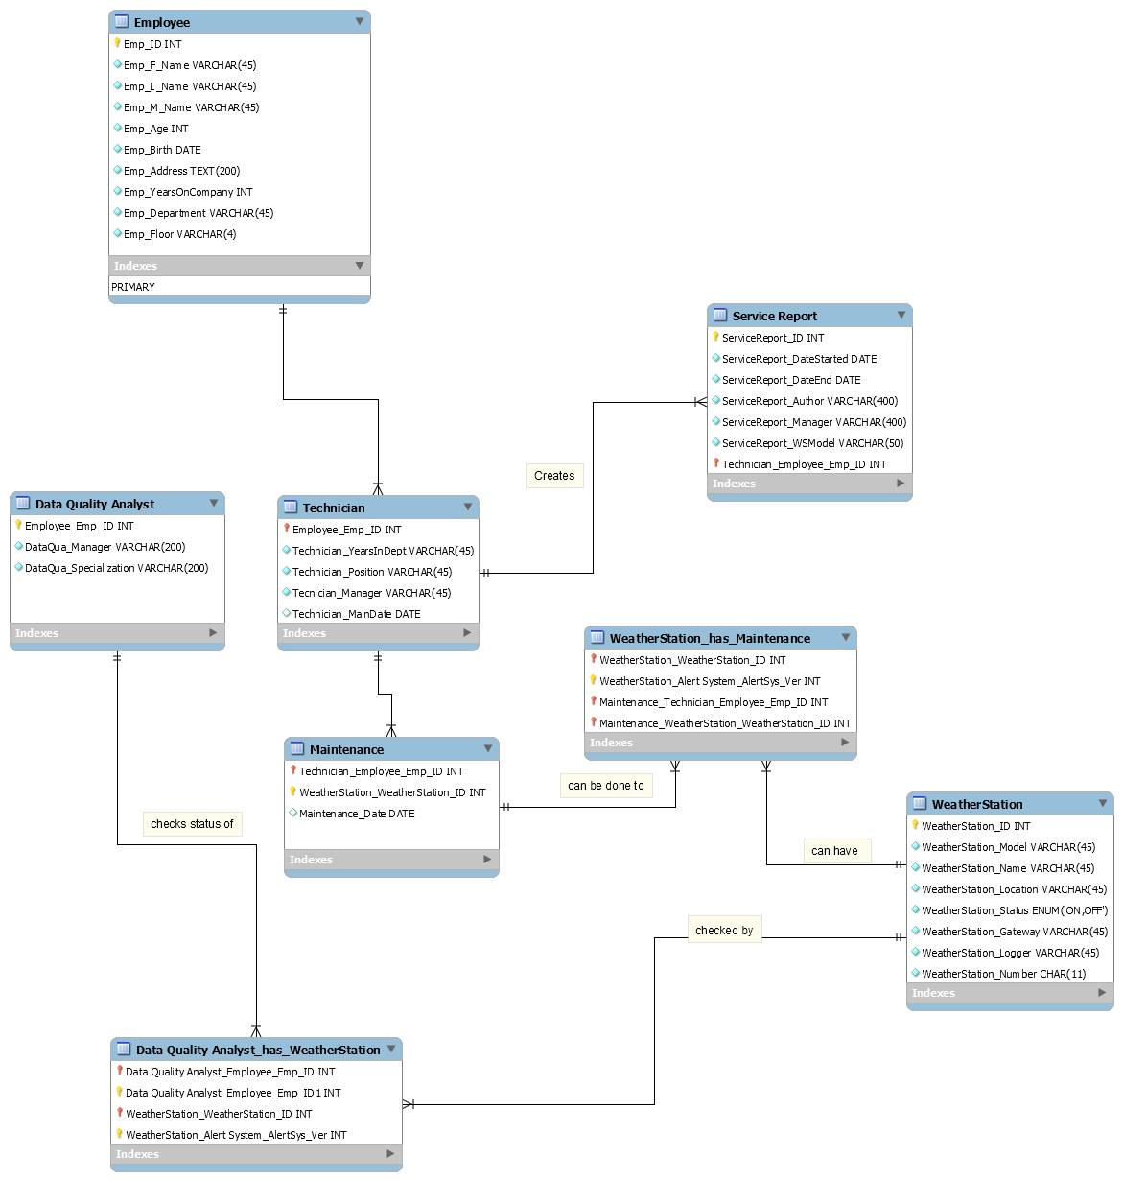

1. Data Dictionary

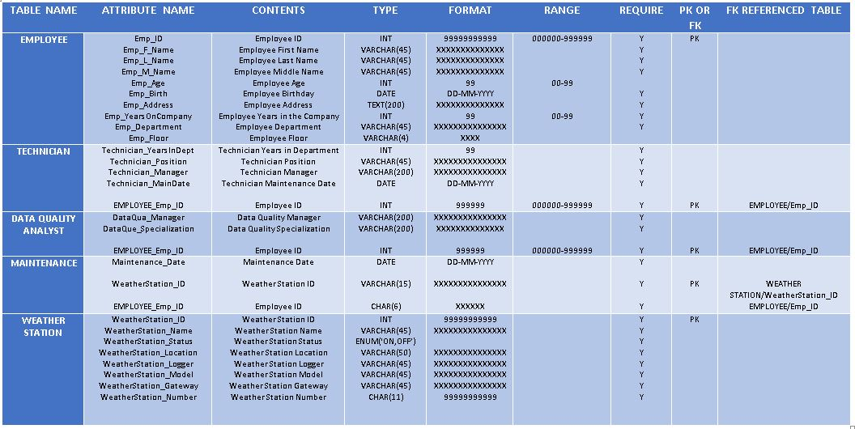

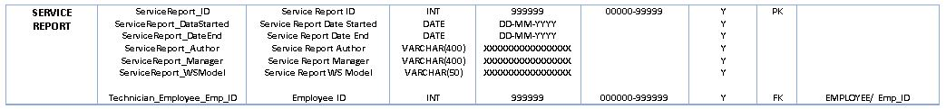

1. Context Diagram

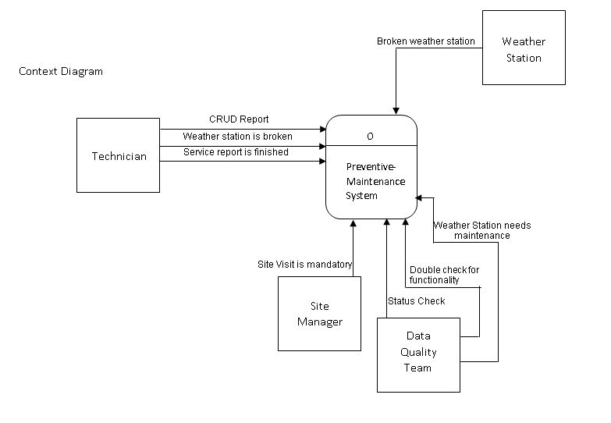

1. Diagram 0

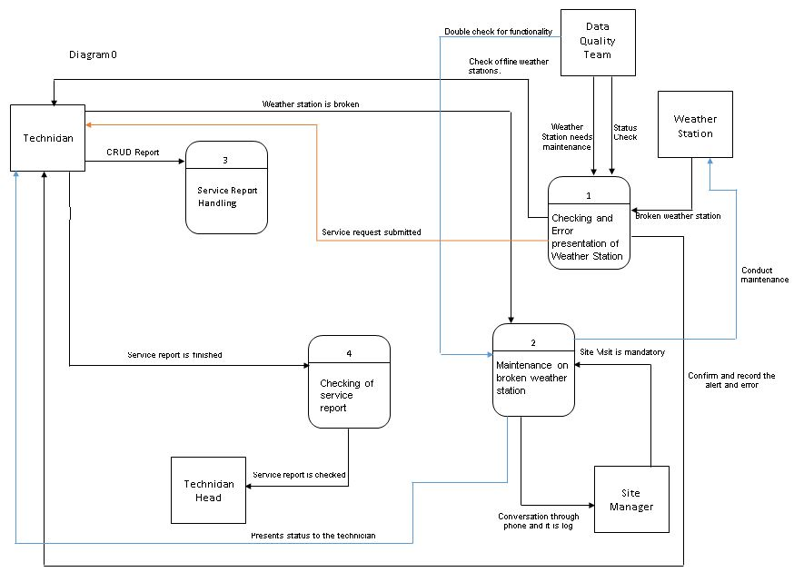

1. Diagram 1

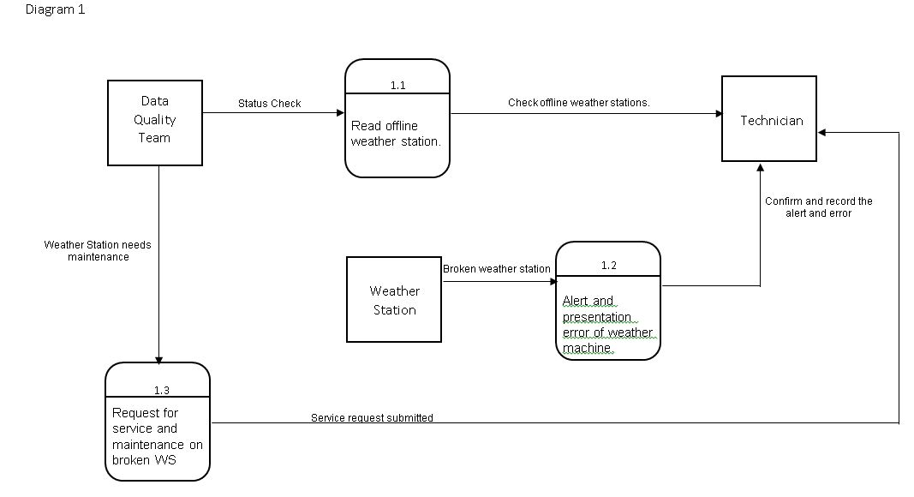

1. Diagram 2

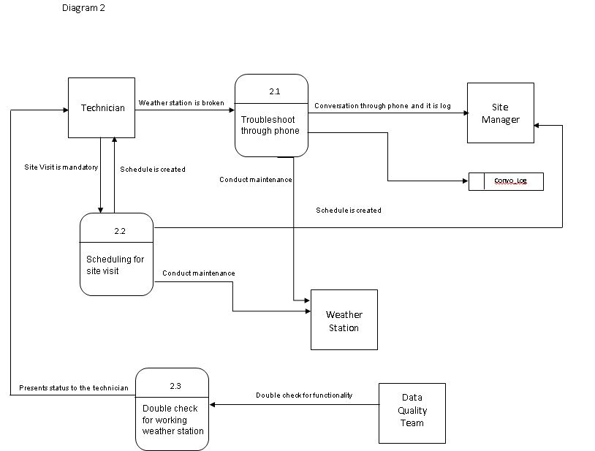

1. 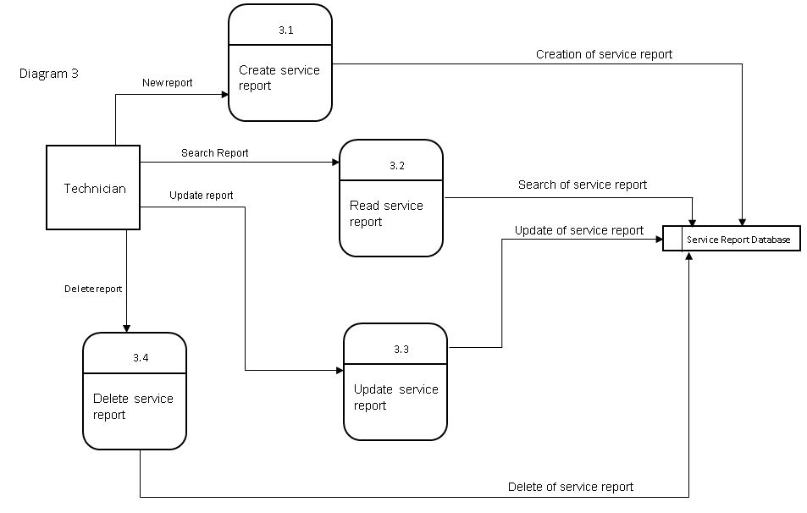Diagram 3
2. Event Table

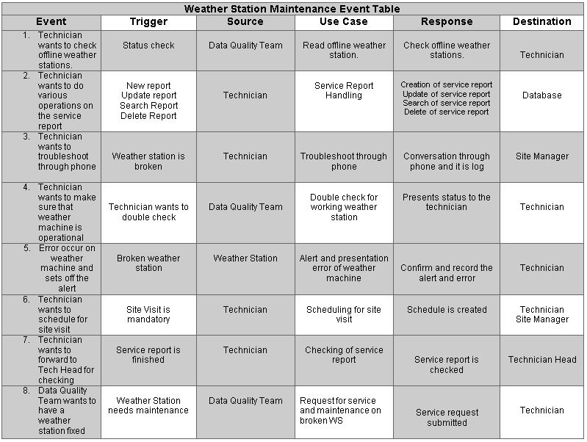

1. Use Case Diagram

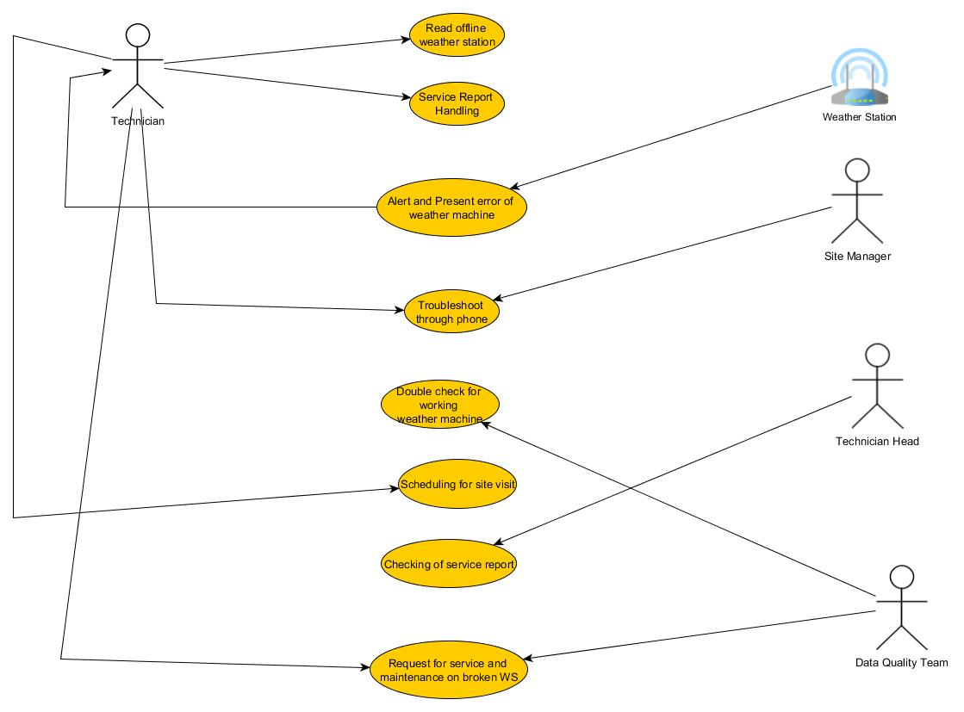

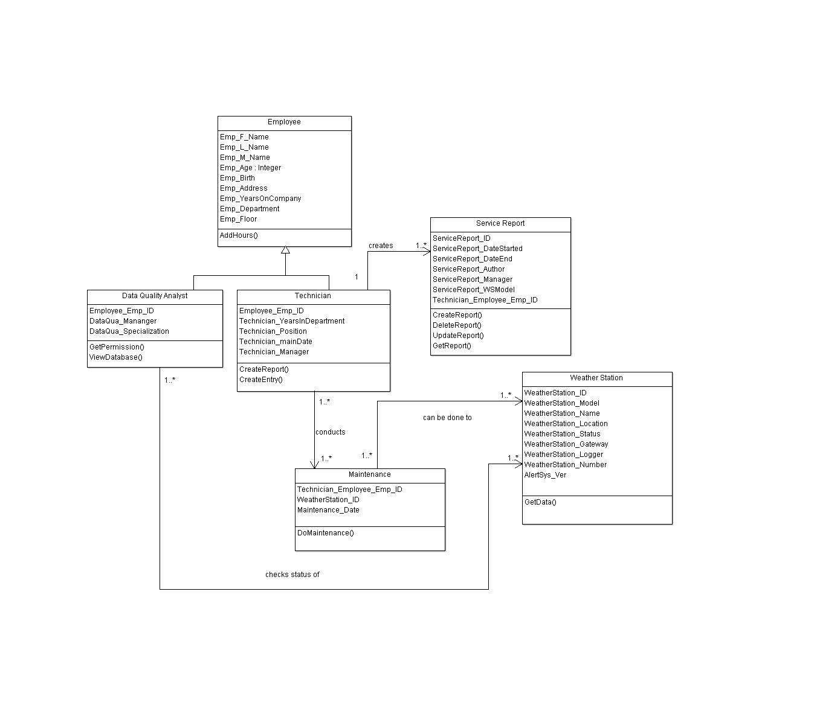

1. Class Diagram
2. Object Diagram

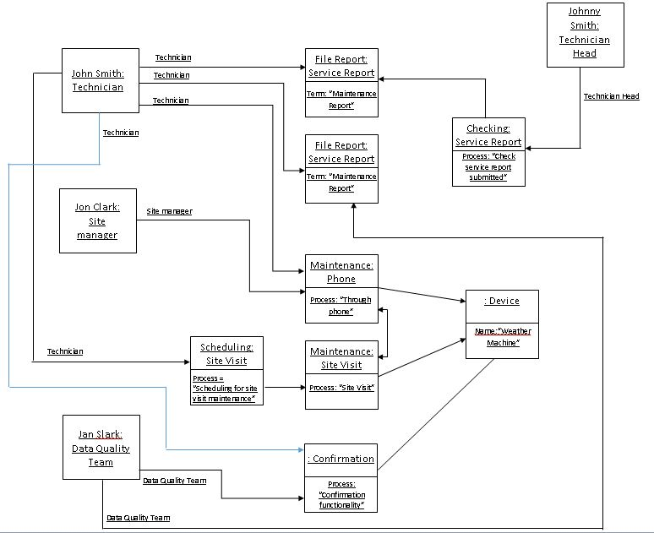

1. State Diagram

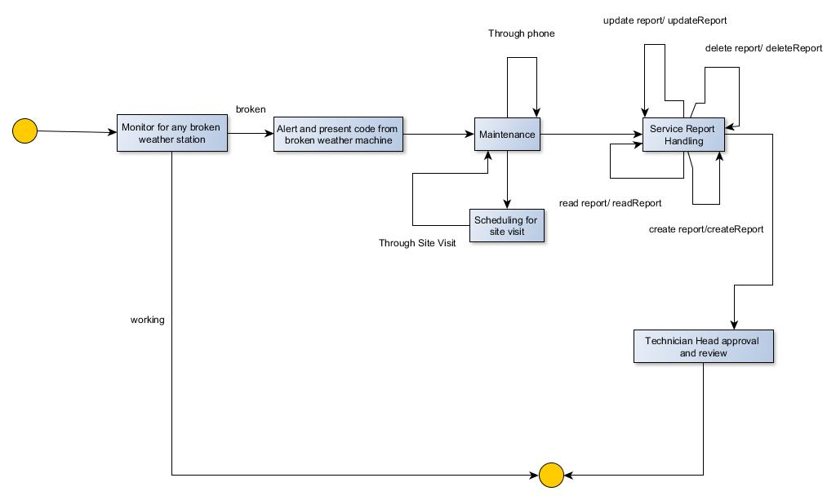

1. Timing Diagram

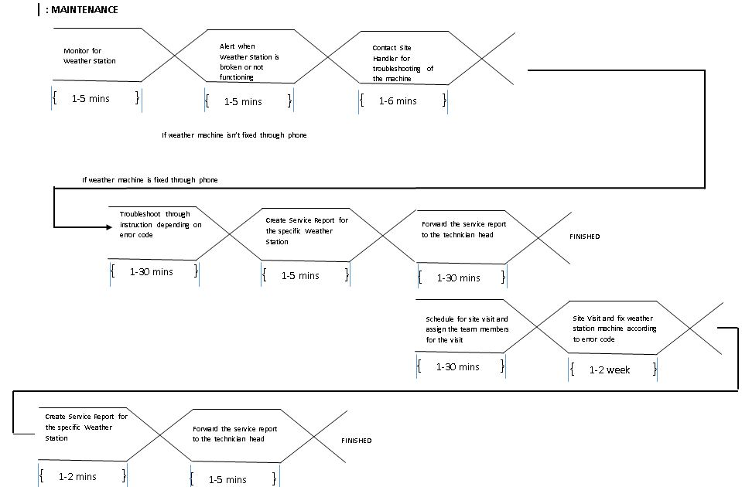

1. Sequence Diagram

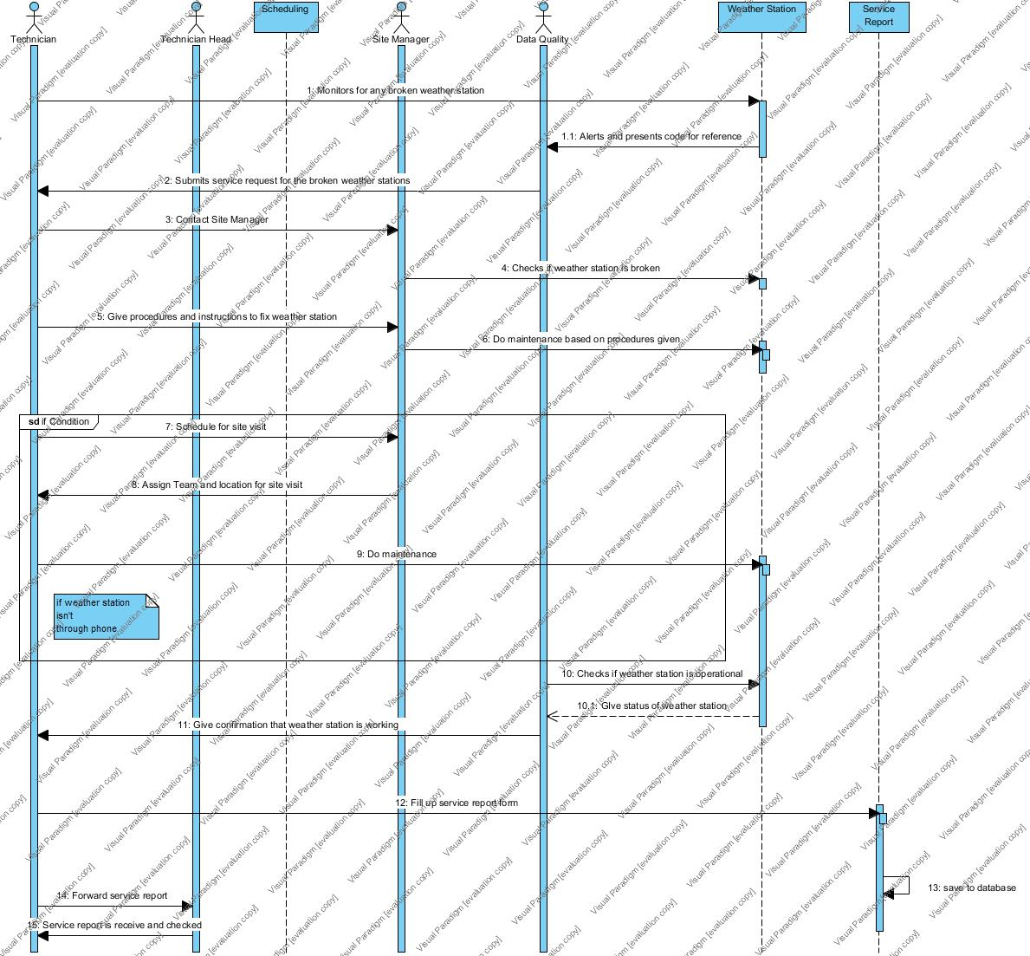

1. Communication Diagram

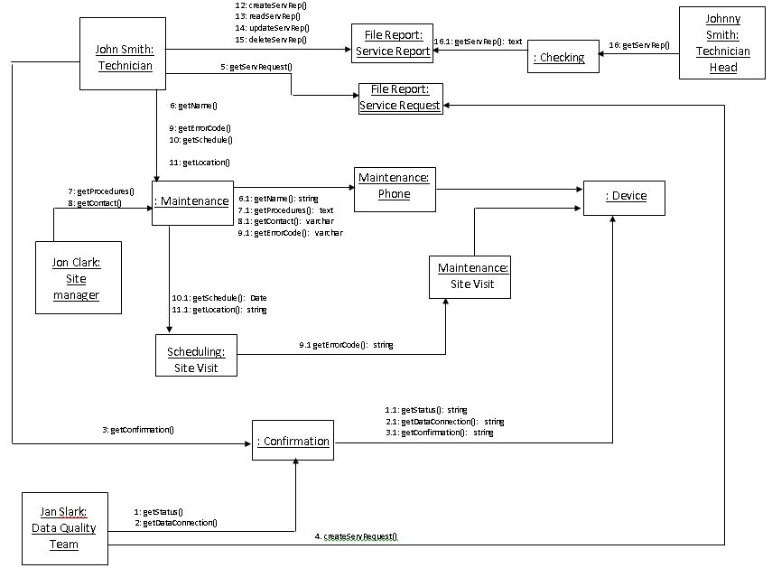

1. Activity Diagram

